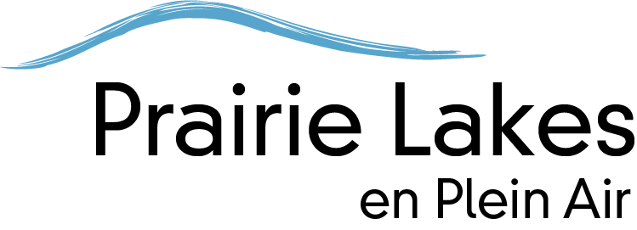
Plein Air in Oils
Instructor: Scott Lloyd Anderson

Supply list

• Cadmium red medium, cadmium yellow med, ultramarine blue, black and white.
• A variety of sizes of oil brushes, linseed oil and odorless turpentine or mineral spirits for medium
• medium cup, brushwasher container or jar w/lid for solvent to clean brushes, paper towels.

Art of the Lakes will supply some easels but bring what you’re used to working on if you have a plein air kit. Contact me if you have questions. scott@twosprucedesign.com and please visit my website to get a sense of what I do, www.ScottLloydAnderson.com
--
Scott Lloyd Anderson
Oil Paintings
www.ScottLloydAnderson.com
651-336-5027

